***EQUIFAX***

CMS Fusion

**REPORTING & INQUIRY POSTING**

**DOCUMENTATION**

Table of Contents

Reporting 1

1. Reporting Home 1

2. SAS 1

3. Quick Frequeny 2

4. Standard Reports 3

5. Project Stats 3

6. View all Reports 4

7. FICO Reports 5

Inquiry Posting 6

**REPORTING:**

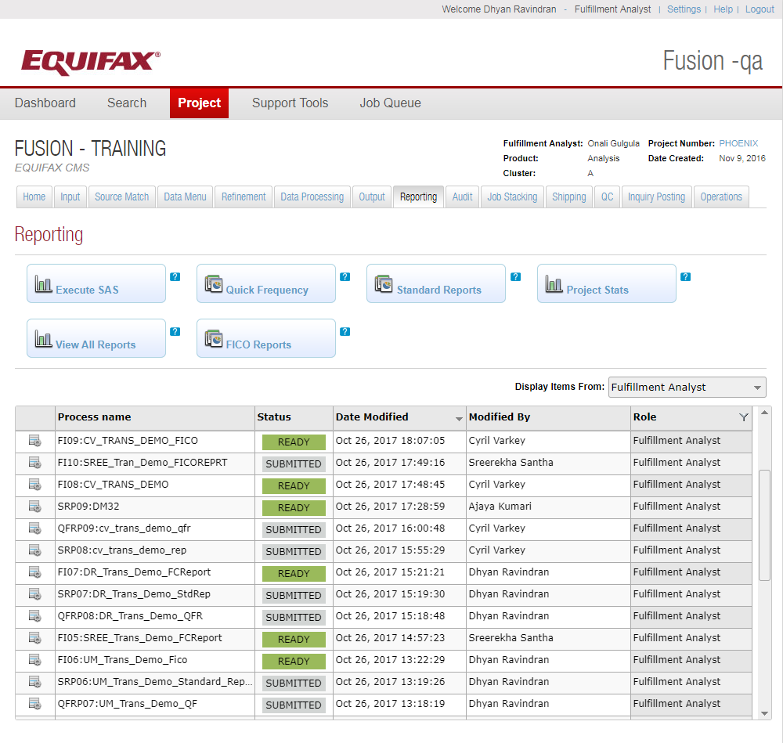

Reporting is basically used to generate Standard Reports and /or SAS (Custom) Reports.

Different type of reports:-

***SAS:*** 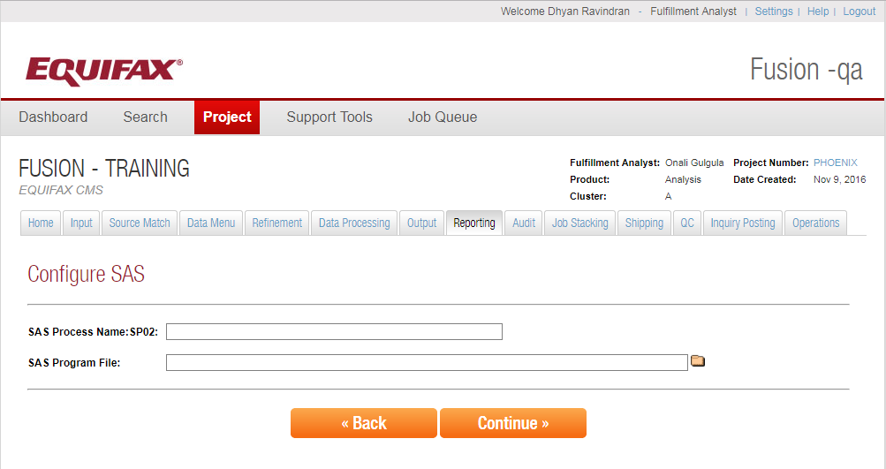

SAS is a third party company that has a report programming product. Write a SAS program which is run by fusion similar to AP module. The input can be a file or the table. Based on the input SAS program it will create the report. Parameter can be defined in input SAS program.

***Quick Frequency:***

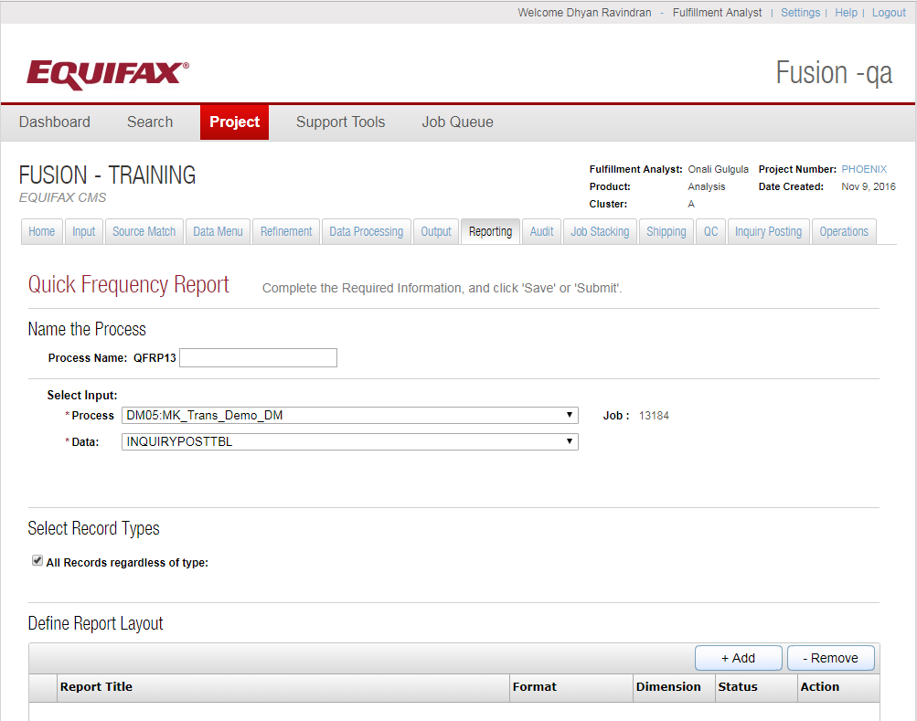Distribution report or quick report. Configurable Multi-Dimension Report based on the input tables. Multiple filters can be applied and based on that parameters SAS code will be generated. And SAS code will then be used to generate the report.

***Standard Reports:***

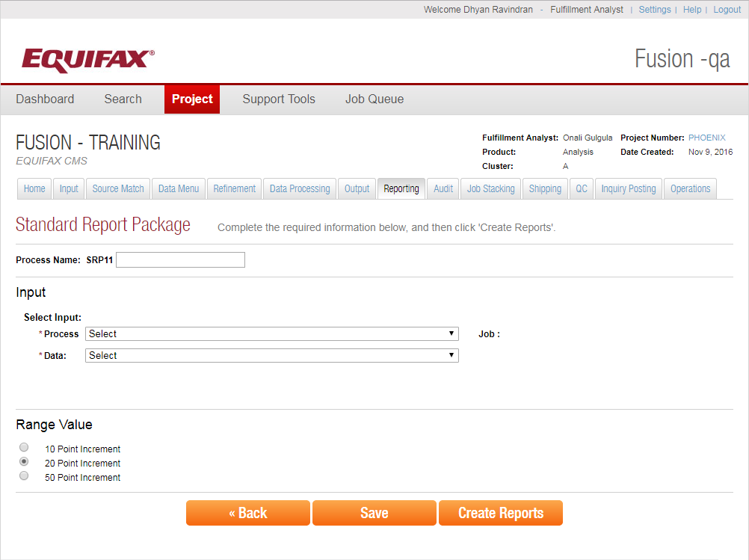

In standard report we don’t have a lot of customization. We can choose Range increment value.

***Project Stats:***

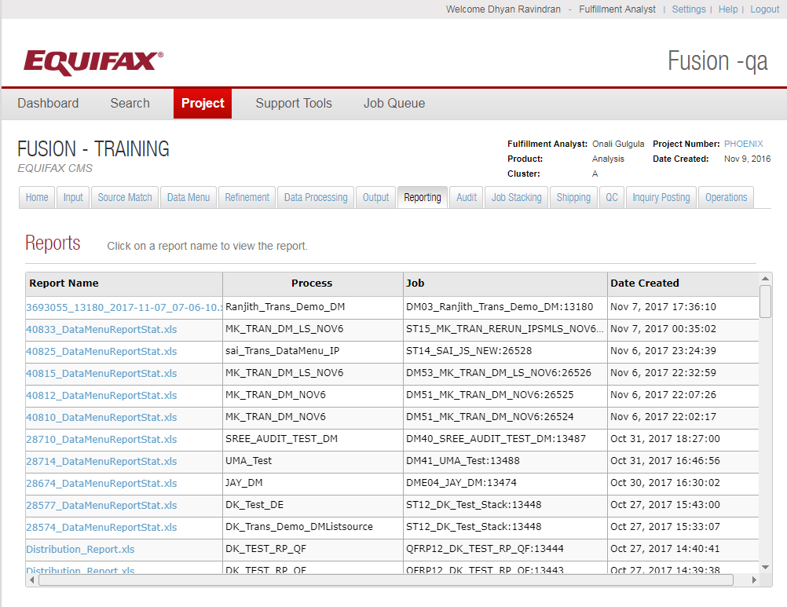

In this select the process and submit it. Generate the stats of all the jobs ran until the selected input process. It will generate the reports on all the steps from start to end. It basically is like a waterfall.

***View all reports:***

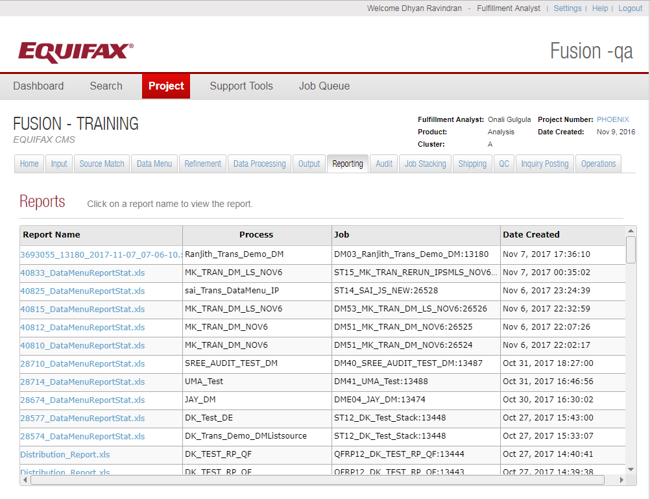

To view the list of all the reports generated.

***FICO Reports:***

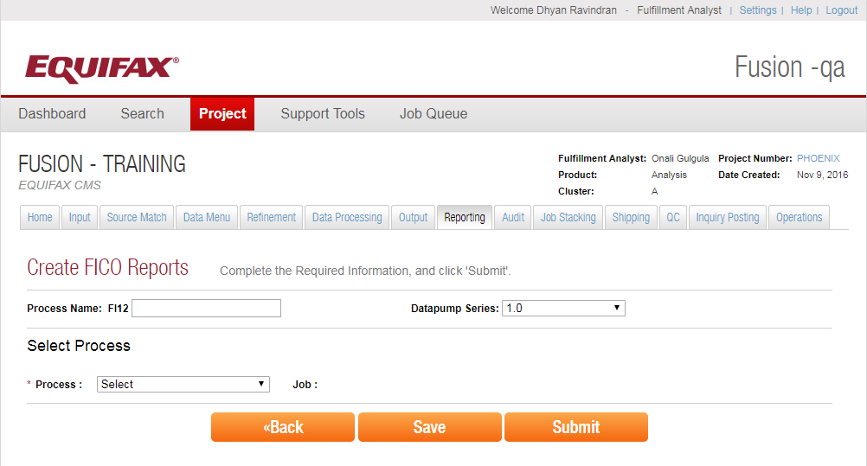

Fair Isaac Company created a model. FICO reports can be generated using that model. It uses pre-configured SAS code to generate distribution report.

**Summary:**

Reporting is used to generate different kind of reports on the selected jobs.

**Inquiry Posting:**

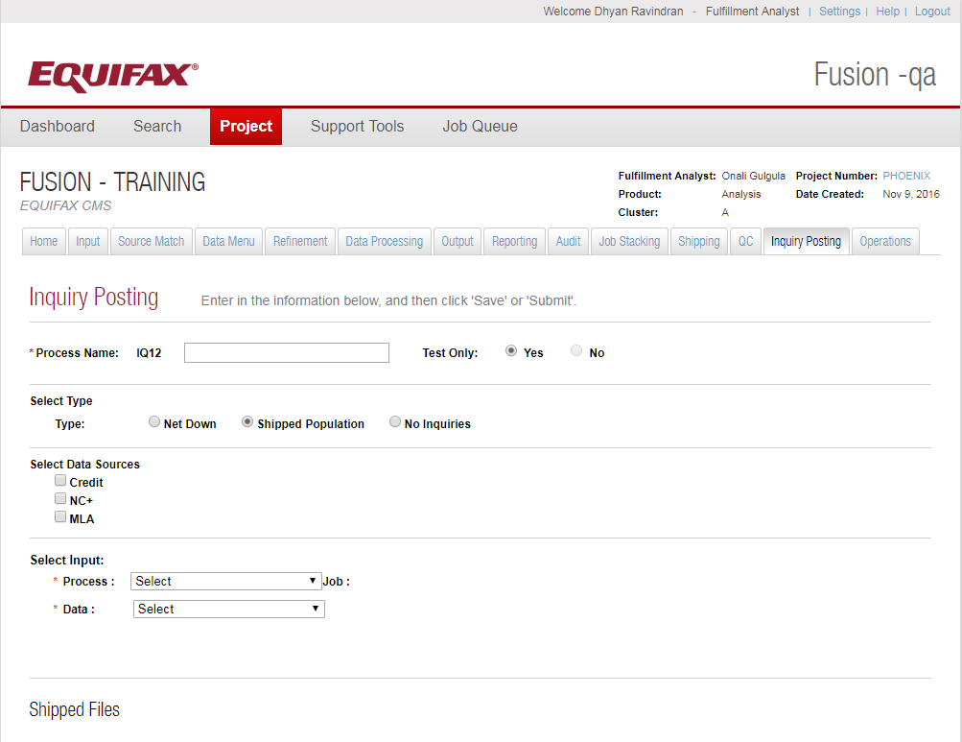

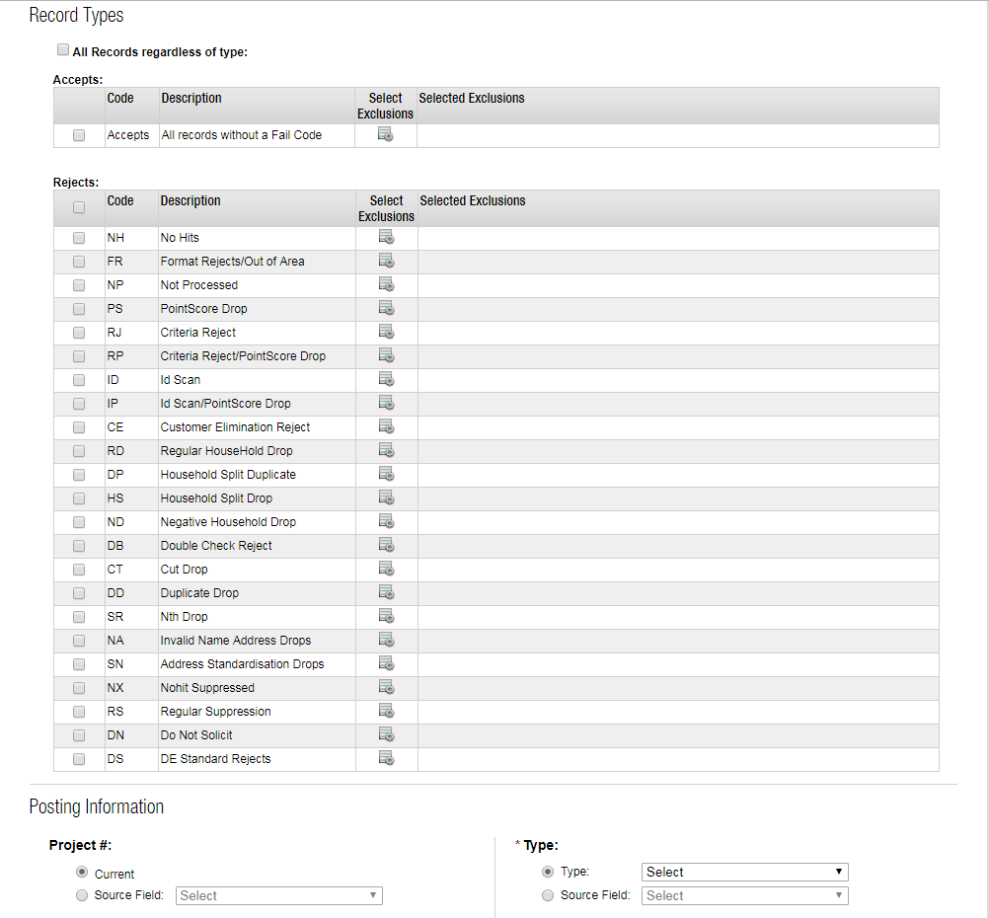

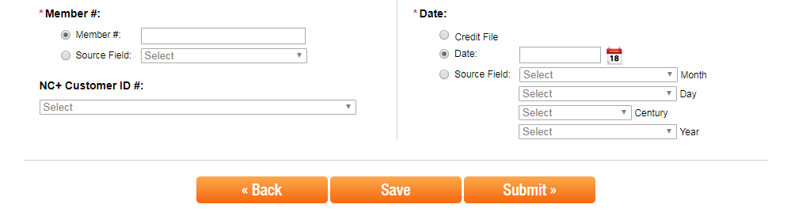

Inquiry Posting is the process to post the inquiry against the consumer’s record for any type of solicitation. This is just to keep the track of who accessed the records. Only soft inquiry can be posted.

Test Only option when chosen then it won’t update the billing system or online system. It means that no inquiry will be posted against the records.

**Type Selection**: There are 3 types of Inquiry Posting.

**Net Down:** Net Down means consumer is sending back a file with the list of records that they used against the total records shipped to them. So the inquiry will be posted against those records only.

**Shipped Population:** When we select type as Shipped Population, then it means that inquiry will be posted against the total records that were shipped.

**No Inquiries:** This type when selected will not be used to post the inquiry against any records but will be used for the project accounting purpose.

**Data Source Selection:** We have Credit, NC+ and MLA data sources to choose from. We can choose which data sources we are posting the inquiry to. We can choose multiple data sources.

**Input Selection:** We have to select input source file and then we have to select the data.

**Shipped date:** We have to choose shipped date.

**Record Type:** This option will be available only when we select type as shipped population to filter the records that we want to post the inquiry to. We can choose all records or a particular (accepted) type of records for which we want to post the inquiry for.

**Posting Information:** When we choose type as Net Down or shipped population then we have to provide or select information like project number, type, member ID, date, and NC+ Customer ID number.